*Florida International University*

*School of Computing and Information Sciences*

CIS 4911 - Senior Capstone Project

Software Engineering Focus

Feature Document

User Story #591

**Team Member:**

Andrew Mitchell

**Product Owner(s)**:

Francisco R. Ortega

**Mentor(s)**:

Francisco R. Ortega

...

**Instructor**: Masoud Sadjadi

# 

# **User Story – Design UI for Multitouch**

* As a User I would like a proper UI Design when using the multitouch so it is intuitive and easy to use.

## **Use Case – View Devices Status**

Use Case

Be able to detect which devices are plugged in at application start up.

Details:

Actor: User

Pre-conditions:

Devices must be installed and working on the PC (Leap, EyeX, Multitouch)

Description:

Use case begins when the user starts up the application. The user then receives visual feedback based on which devices are currently plugged in at the applications startup.

Post-conditions:

Boxes must be drawn in the ‘Mode Box’ corresponding to each device. Blue for multitouch, Green for Leap Motion, Red for Tobii EyeX.

Decision Support:

Frequency: Often. It is useful to check which devices are currently working. It also gives us a quick reference to see if the devices are not currently running (which gives the user a chance to fix it outside our program).

Criticality: High. This is core in detecting which devices are currently active. This is very important for future UI and Usage Design, to see which devices will do what when some devices are missing.

Risk: Low. We have to work with multiple devices, but it should be fairly basic implementation.

Reliability: Highly.

Mean time to Failure – Almost never. If the device shows up on the status bar, the device should work for our application. If it doesn’t we know it will not work (and shouldn’t accidently work).

Availability – Always available in the mode box (Mode box may appear only sometimes).

Performance:

N/a

Supportability:

Must work with ACER Multitouch.

Leap motion device

Tobii EyeX

Modification History:

Owner: Andrew Mitchell

Initiation date: 02/28/2016

Date last modified: 02/28/201

## 

## **Use Case Diagram**

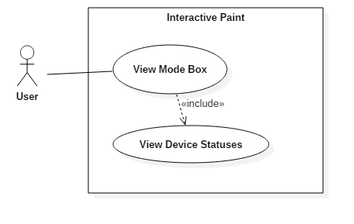

## **Sequence Diagram**

## 

## 

## 

## 

## 

## 

## 

## 

## **Class Diagram**

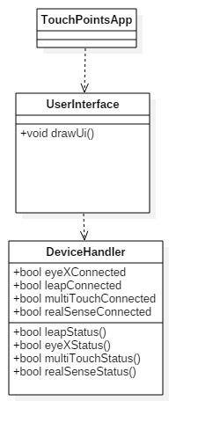

## 

## **Unit Test**

Sunny Day :

* Started application with all 3 devices plugged in
  + Successfully drew all 3 color coordinated boxes.

Rainy Day Tests :

* Started Application with leap and multitouch but without Tobii EyeX
  + Drew the Leap Motion and multitouch squares successfully. Did not draw Red EyeX Box.
* Start App. with Multitouch, no leap or eyeX
  + Drew blue box. Did not draw leap or EyeX box.
* Start App without any devices
  + Drew no boxes inside the mode box.
* Start App with Leap only
  + Only drew green box.
* Start App with EyeX Only
  + Only drew red box.
* Start app without Multitouch, but with Leap and EyeX
  + Drew green and red box.

## 

## **Integration Test**

Works with current ‘touchpoints app’. These features work correctly given the proper devices are plugged in (or not plugged in). It works without or with the following devices

Tobii EyeX

Leap Motion Controller

Acer Multitouch Screen

Real Sense Deptch Camera

Currently integrated with Device Modes (Enable / disable the boxes when the devices are enabled or disabled).

## 

## **User Guide**

Start up the application with the correct devices running and working. Open up the mode box (If eyeX is enabled you must ‘gaze’ into the bottom right hand corner). View the 4 Boxes to see whether or not the devices are enabled.

Here we have an image with the multitouch plugged in.

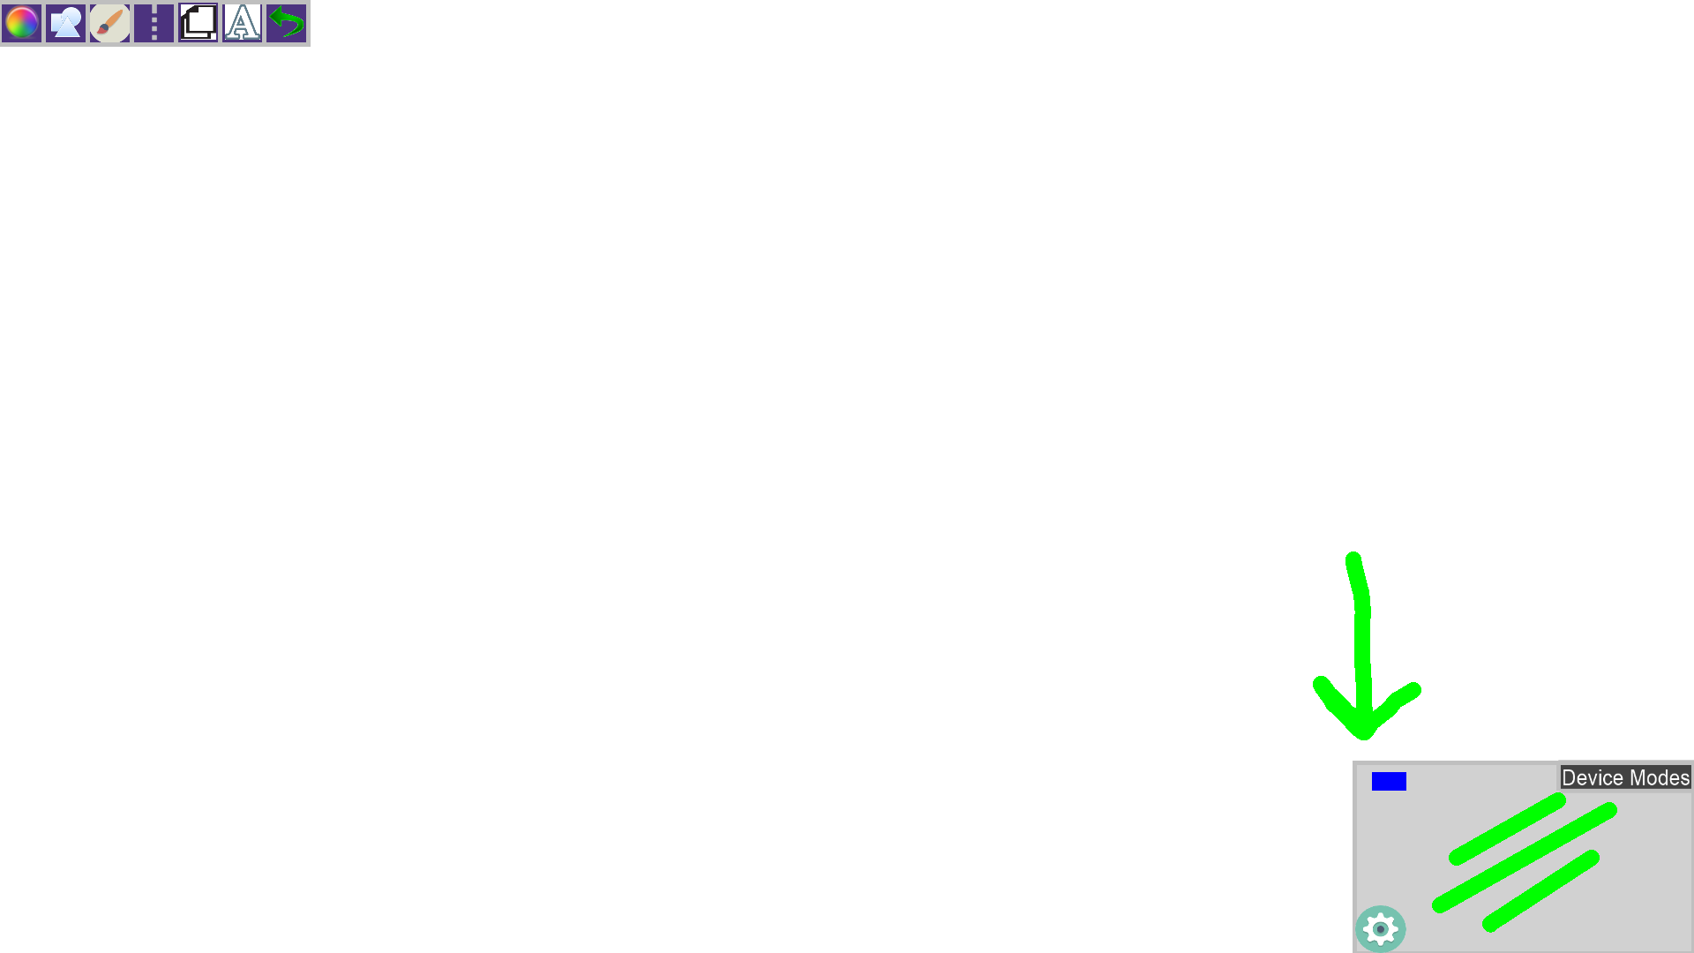

The blue box indicates multitouch. Eyex is indicated by a red box, green box indicates leap motion, and Yellow box indicates real sense device.